**CSS Assignment _Spark & Build Web Dev**

***Tabitha Wanjiru Muhiukia***

1. Webcss.html file

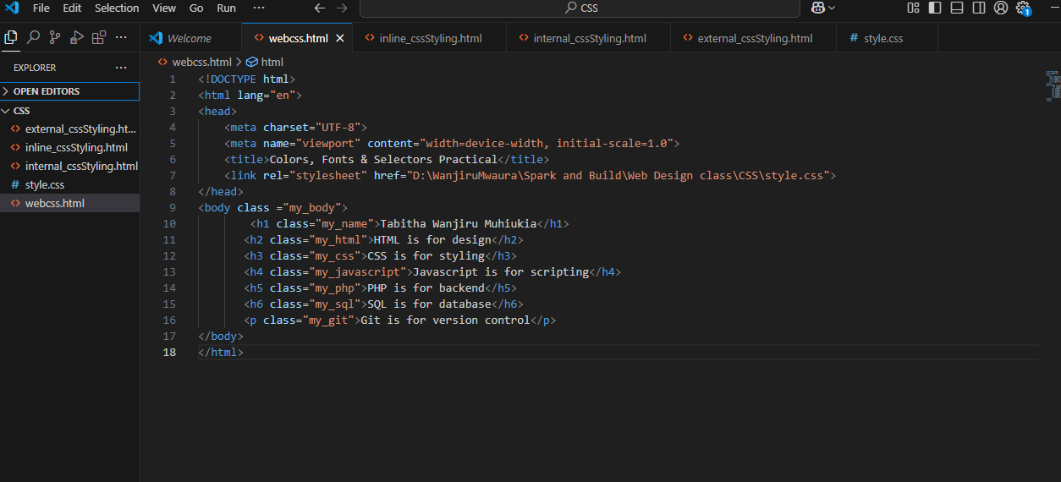

1. Style.css File

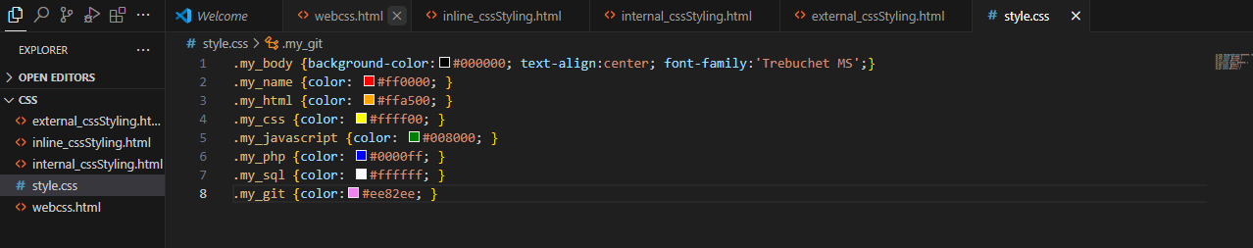

1. Styling with CSS: inline, internal and external

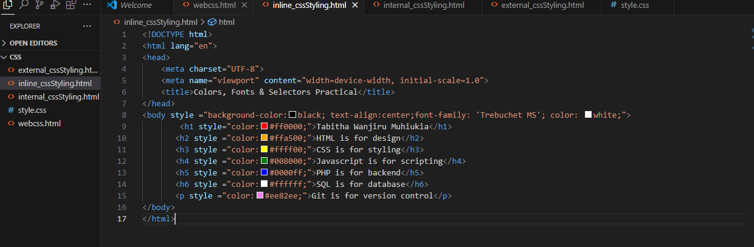

Internal CSS styling:

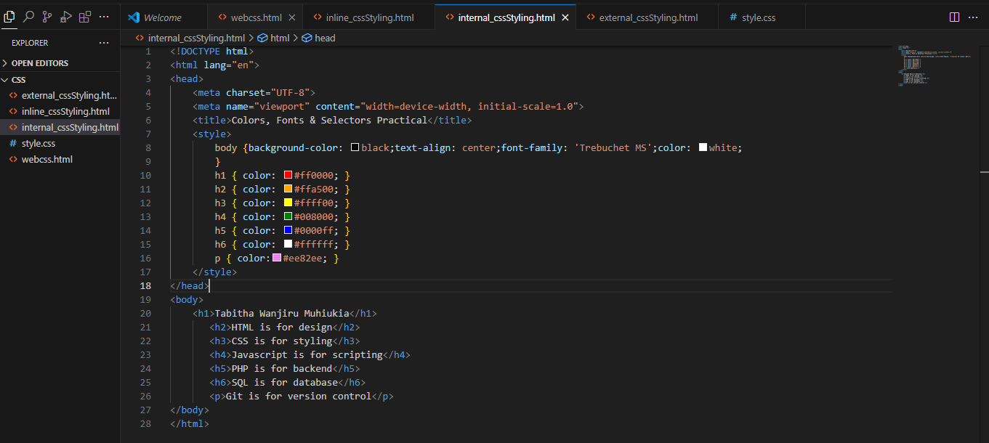

External CSS styling:

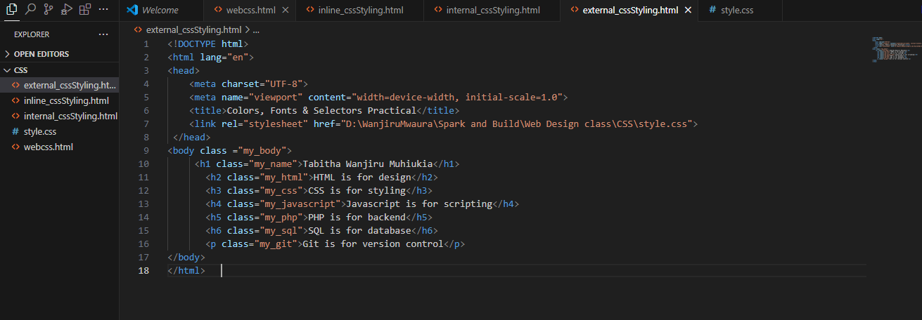

All these styling (inline, internal and external) gives the same output below:

